Greetings

Should the researcher be required to conduct research within the SAPS via questionnaires and interviews, in terms of the National Instruction 4 of 2022 (attached), which requires the submission of five (5) supporting documents for the consideration of applications to conduct research, which include:
· Annexure A: Pro-forma research application (attached);
· Annexure B: Pro-forma undertaking by a researcher (attached);
. Population and Sample (attached);
· Final and approved research proposal; and
· A letter or certificate by the academic institution under whose patronage the research is conducted regarding the ethical clearance of the research; indicating that the approved proposal was approved by the particular institution’s “Research Ethical Committee” and can be forwarded to Research Nodal Point: Research Nodal Point:Ntlou AR ntlouar@saps.gov.za and MadumoS@saps.gov.za

PLEASE TAKE NOTE OF THE APPLICATION PROCESS
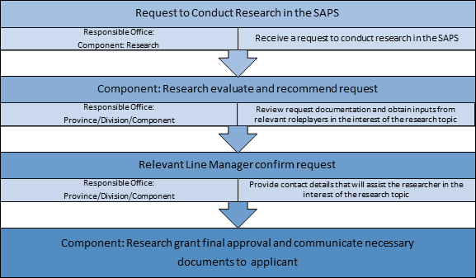

Regards

